Brightness calibration discussion

Problems:

* Images have different background levels
* Bright objects have values independent of the background value
* Brightness offset varies drastically between bright objects

What I’ve tried:

The background levels can be aligned by estimating the background intensities, I have done this in multiple ways…

The most basic way to accomplish this is by taking the mean value of both images and adding the difference to each pixel in one image. The value can be improved by filtering out bright objects (iteratively removing pixels above the median) before calculating the mean.

A more effective way is to apply a median filter (split image into smaller squares and calculate the median of the square) to an image of the difference between the 2 images, producing a varying offset filter that can be applied to one of the images. The advantage to this is that ever pixel gets an offset value representative of the area around it.

So, aligning the backgrounds is easy, however the bright objects remain at different intensity levels. By normalising the two image data pools, we can see more clearly if a multiplication factor applied to one of the images could align their brightness’s. However, in most cases a multiplication factor doesn’t work because a different factor is needed for each star/bright object. If we give each object a different multiplication factor to bring it up to its corresponding brightness in the other image, it will be impossible to identify any real changes in the images.

I made a similar filter designed to give varying multiplication factors, by blurring an image of the brightness ratios between the images, which is multiplied to the second image. In this filter, only the values of bright objects were considered when calculating the square medians. This was because the backgrounds are aligned, so if the whole data pool was included the filter would be an image largely made up of numbers around 1. This method wasn’t successful either, and the more accurate the filter becomes, the more pointless it becomes as it wouldn’t show the genuine changes.

Ideas for future attempts:

* Looking into the point spread function of the telescopes and removing the effects from the images before aligning them.
* Performing photometry on a few well-documented stars in both images and comparing their brightness to what’s given in SIMBAD, this might shed some light on the intensity relationship between the images.

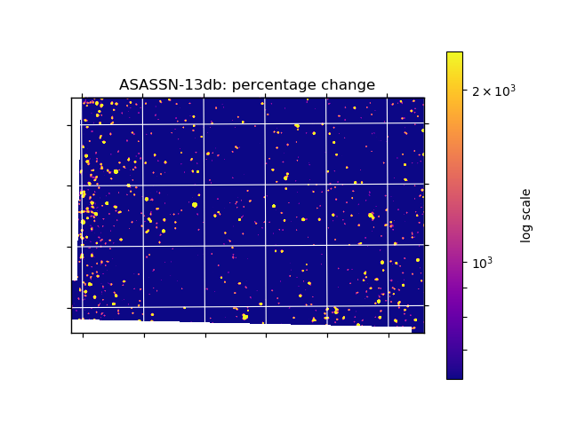

Images normalised only.

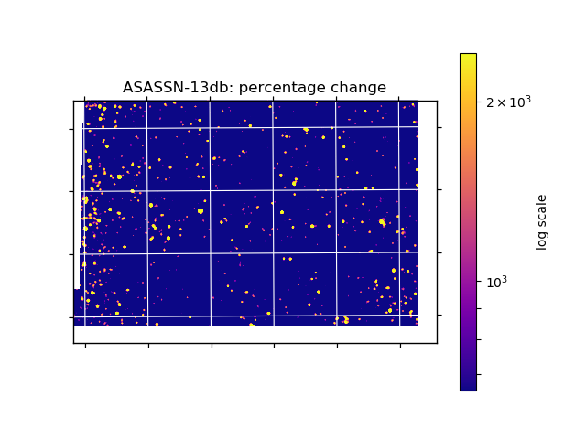

Images normalised, and an offset filter applied.

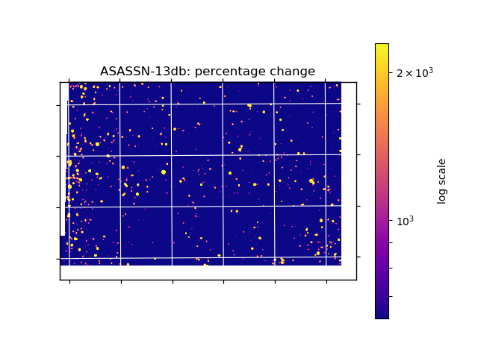

Images normalised, and a ratio filter applied.

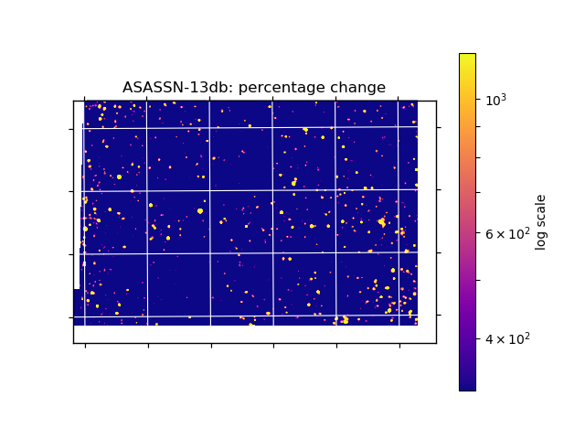

Normalised, offset filter added, ratio filter only recognising stars applied.